2016 Safety Stand-Down: Getting Started

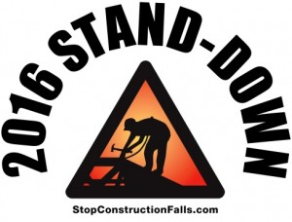

MAY 2 – 6

Unsure of how to make the National Safety Stand-Down work on your site?
Here is a simple and cost-free plan to get you started!

The National Fall Prevention Safety Stand-Down is a voluntary event for employers to talk directly to employees about fall hazards, protective methods, and the company’s safety policies, goals and expectations. This day-by-day plan for the Stand-Down provides activities that can be tailored to your jobsite. Each suggestion listed, along with others you will find on stopconstructionfalls.com, can be used any day of the week. While not all employers can commit to an activity all 5 days, everyone can do something to have an impact on safety! Make accessing these materials even easier by downloading Harness’s new Stand-Down mobile app.

If you participate in the Stand-Down in any way, tell us about it! Answer some questions about your activities on OSHA’s website after the Stand-Down and you’ll receive a Certificate of Participation signed by Secretary of Labor Thomas E. Perez. Or just send us an email at falls@cpwr.com to share your story. If you include pictures with permission to use them, we may post them on this website.

Here are some Stand-Down activities:

Day 1: Monday
Share real life stories! Use examples of contractors who are doing fall protection right, or alternately, of workers who have been injured or killed in a fall to drive the message home.
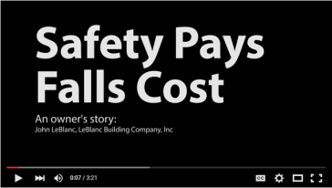
Videos –
- Safety Pays. Falls Costs – Hear how the owner of this residential framing company designs safety into each of his job sites. John LeBlanc talks about what happened when one of his workers died from a fall on a LeBlanc job site. The death had a profound effect on LeBlanc, and led to a complete restructuring of his company’s safety procedures. He started from scratch but you don’t have to.
- A construction framer talks about protecting his crew from falls (4 mins) - Mike Pelky is a residential rough framer working in Arizona. His company designed and instituted a fall safety program. Mike was there from the start. In this video he shares how they did it and why he thinks fall protection is a good idea.
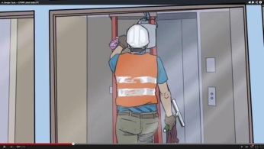
- Preventing Falls Through Skylights – English; Spanish (Español) “Everybody seems to think that we’re invincible. At least I used to think that.” So begins a digital story about Joe, a 45-year old roofing supervisor in California who died tragically after he fell through a warehouse roof skylight while on the job. He fell 30 feet onto a floor, and died from his injuries. OHB’s California Fatality Assessment and Control Evaluation (CA/FACE) program produced a five-minute digital story with two of Joe’s co-workers highlighting the events that led up to his death and what could have been done to prevent it.
- A Simple Task - Fatal Ladder Fall – This 2 minute video using photos and animation recreates the real-life series of events that led to the death of a 33-year-old construction worker from a ladder fall -- and how it could have been prevented.
Download Video (right click & save)
- La seguridad paga, las caídas cuestan (Spanish) – Hear from a roofer in the residential construction industry on the importance of using fall protection.
- La Salud no Tiene Precio. Construcción: Protéjase en el Trabajo. (Spanish) – Hear from a roofer in the residential construction industry on risks he faces daily on the job.

Check out CPWR’s Fatality Maps – interactive maps pinpoint fall-related fatalities across the US and share news reports and information about those killed.
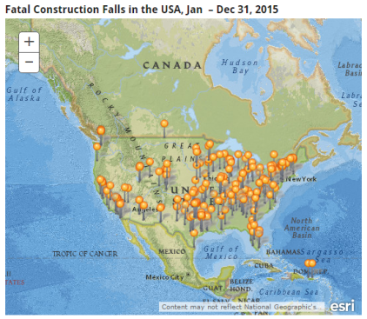

The National Institute for Occupational Safety and Health (NIOSH) and State Fatality Assessment and Control Evaluation (FACE) Reports and Products -
Investigations conducted through the FACE program allow the identification of factors that contribute to these fatal injuries. This information is used to develop comprehensive recommendations for preventing similar deaths. Below is a list of fall-related FACE reports.
- Construction Laborer Dies After Falling Through Temporary Bridge “Catch” Platform, 75 Feed To Ground – New Jersey
- Falls From Scaffolds can be Prevented – Michigan
- A Day Laborer Dies When He Falls from a Scaffold
- A House Painter Dies When He Falls Through a Roof Opening – California
- A Roofing Supervisor Dies When He Falls Through a Skylight – California
- Municipal Lead Custodian Dies in Fall from Mobile Scaffolding – Massachusetts
- Carpenter Feel from the Roof of a Single Family Home Under Construction – Massachusetts
- A Day Laborer Dies When He Falls Off a Scaffold – California
- A Plumber Dies When He Falls from the Second Floor of a Building after Stepping on Unsupported Plywood Formwork – California
- Laborer Dies When He Falls 35 Feet From a Scaffold After Being Electrocuted – California
- Roofer Dies After Falling from Ladder or Roof – Washington
- Carpenter Died from Extension Ladder Fall – Michigan
- Painter Falls from Stepladder – Washington
- Laborer Falls Through Roof Opening – Washington; Fatality Narrative as slideshow
- Construction Laborers Fell From Ladder – Iowa
- Steel Worker Falls from High Bridge and Dies – Kentucky
- Carpet Installer Dies After Falling 30 Feet at a Commercial Job Site – Washington – Youtube Video about Carpet Installer Incident
- Master Stonemason Dies in a 30-foot Fall From a Handmade Work Platform Attached to a Powered Industrial Truck – New York

Success Stories from the 2015 Stand-Down – Share examples of organizations, worker safety groups, construction companies, and other stakeholders that engaged in last year’s stand-down and produced results.

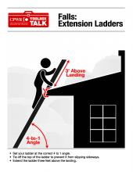
Day 2: Tuesday
Give a Toolbox Talk! Toolbox Talks are short and easy on-site trainings that only last approximately 5-15 minutes each. They can be given at the beginning of the shift. Workers attending the talk should be encouraged to ask questions and discuss the topic. This increases the likelihood they will remember the information. Below are some ready-to-use Toolbox Talks from CPWR. Toolbox Talks on a second topic can also be substituted for another activity later in the week.

Possible Toolbox Talks:

Falls: Extension Ladders
Falls: Step Ladders
Focus Four Toolbox Talks: Falls from Ladders
Falls from Scaffolds
Focus Four Toolbox Talks: Falls from Scaffolding
Falls from Rooftops
Falls Through Holes and Openings
Focus Four Toolbox Talks: Falls through Skylights and Holes
Falls: General Protection and Awareness
Falls from Moving Machinery
Aerial Lifts
Equipment: Getting On and Off

Day 3: Wednesday
Use the NIOSH Ladder Safety phone app with your crew! The app features a graphic-oriented guide for ladder selection, inspection, positioning, accessorizing, and safe use. New for 2016, the app now includes step ladders! The app is also available in Spanish (to view and use, select Spanish as the phone language). Review the app features together as a group and then ask the smaller groups to play with the app or practice using it on site together, giving workers the opportunity to ask questions about its use. Visit the NIOSH Ladder Safety Mobile Application website to learn more.
Download on iPhone/iPad
Download on Android devices

Day 4: Thursday
Review your fall prevention program. OSHA recommends asking the following questions:
- What types of falls could happen? Based on the work being done, and the types of subcontractors on site, what are the possible fall hazards?

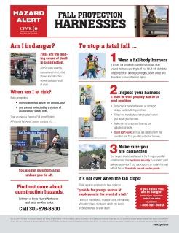
Consider conducting a job hazard analysis with workers as a group for more specific tasks. According to OSHA, a job hazard analysis is a technique that focuses on job tasks as a way to identify hazards before they occur. It focuses on the relationship between the worker, the task, the tools, and the work environment. Ideally, after you identify uncontrolled hazards, you will take steps to eliminate or reduce them to an acceptable risk level. For more information, visit http://www.safetyworksmaine.com/safe_workplace/safety_management/hazard_analysis.html

- What needs improvement? Is your program meeting its goals? Are you experiencing injuries or near misses? Are employees aware of the company's fall protection procedures?
- What training have you provided to your workers? Does it need revision?
- What equipment have you provided to your workers? Is better equipment available?

Day 5: Friday
Conduct a Fall Protection Demonstration. Have a contractor representative, supervisor, on-site safety professional, or guest expert demonstrate how to properly fit, wear, and use fall protection. The following resources provide tips:
Fall Protection Harnesses Hazard Alert – a one page illustrated document on how to wear harnesses properly.
Spanish
Personal Fall Arrest Systems Brochure – a handout with illustrations for residential workers on how to use a personal fall arrest system properly (MA Dept. of Public Health).
English
Spanish (Español)
Portuguese
7 Steps to Ladder Safety – a one page graphic illustration on how to use a ladder safely

Unsure of which fall protection is best suited for your job and workers? The online tool, Fall Protection Resource for New Home Construction, found at http://www.ot.wustl.edu/fptech/index.htm, describes over 150 fall prevention devices. Search by the type of fall protection device needed (anchor for personal fall arrest system, scaffold, guardrail, etc.), or by the phase of construction fall protection is needed for (floor joist installation, truss setting, roof sheathing, etc.). At least one close up picture of each fall prevention device is shown, the device purpose and installation are described, cost and manufacturer are provided, and links to the device manual, vendors, and video are provided when available.

After the Stand-Down:
Print Certificates of Participation from OSHA! Employers will be able to provide feedback about their Stand-Down and download a Certificate of Participation signed by Secretary of Labor Thomas E. Perez following the StandDown at https://www.osha.gov/StopFallsStandDown/index.html#certificate.

Tell us your Success Story! Email falls@cpwr.com with details and photos from your event(s). If you give us permission, we may feature them on stopconstructionfalls.com.

Hand out hardhat stickers for participation! CPWR has developed stickers to help raise awareness of the Campaign to Prevent Falls in Construction. These stickers can be affixed onto hardhats or equipment on a work site, to spread the word. To order, email falls@cpwr.com.

For even more ideas on how to participate in the Stand Down, or to improve your fall prevention efforts year round, visit the rest of stopconstructionfalls.com, or check out NIOSH and OSHA’s sites.

